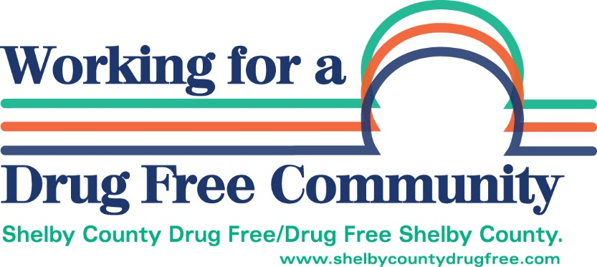

MEMORANDUM OF UNDERSTANDING (MOU)
FOR GRANTEES
1. This agreement between Shelby County Drug Free Coalition (SCDFC) and
Name________________________________Orginization___________________________________
from _May 1 – April 30, 2022 (Date) until terminated by mutual agreement:
SERVICES AND RESPONSIBILITIES
2. SCDFC Shall is responsible to:
(a) Set policies for staff and programs;
(b) Formulate goals and objectives in compliance with its funding sources;
(c) Oversee the daily operations of its activities and programs;
(d) Direct any SCDFC staff and volunteers working on its activities and programs;
(e) Jointly se goals and objectives for staff and volunteers, and negotiate and approve their activities;
(f) Create and follow its strategic plan within the requirements of its funding source;
3. Grantee Member Name shall be responsible to:
(a) Actively serve on one committee;
(b) Provide quarterly reports to Shelby County Drug Free Coalition;
(c) Recognize SCDFC on any literature, media, T-shirts, etc used in promotion of program funded by SCDFC.
Confidentiality
Both parties agree that they shall be bound by and shall abide by all applicable Federal and State statutes and regulations pertaining to the confidentiality of client records and information, including volunteers. The parties shall not use or disclose any information about recipient of the services provided under this agreement for any purpose not connected with the parties contract responsibilities, except with the written consent of such recipient, recipients’ attorney, or recipients’ parent or guardian

____________________________________________ ____________________________________________
GRANTEE SCDFC – EXECUTIVE DIRECTOR

