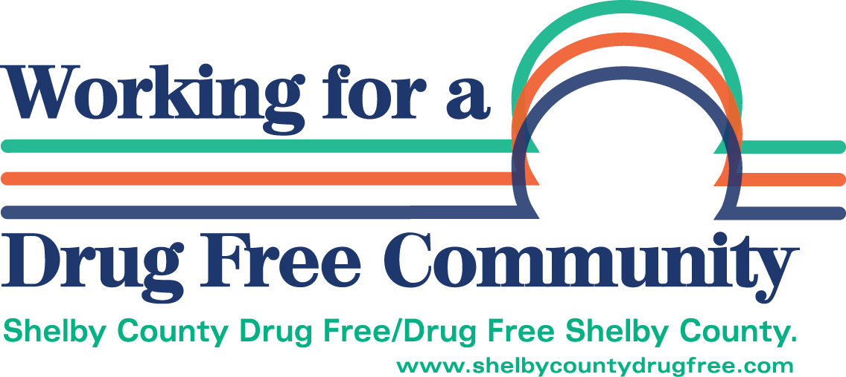

2025 Shelby County Local Drug-Free Communities Fund
Application Instructions/Form

Funding Period: April 2025 - March 2026

Application Packet
- Grant Application Cover Form. Applicant Information Sheet

- Project Narrative. Provide detailed and specific answers to each question. Be sure to answer all questions. Utilize the Problem Statements and Objectives as your foundation.

- Budget Detail. Per the State Board of Accounts: Under the terms of OMB Circular A-122, certain costs incurred by entities are not allowable as charges to grants. These are: Bad debt expenses, contingencies, contributions and donations expenditures, entertainment expenses, fines and penalties, interest and other financial cost and charges representing the non-recovery of cost under grant agreements. The purpose of the budget form is to describe all expenses incurred in the delivery of the service. Total revenue should reflect the total amount of dollars related to the delivery of service.
All dollar amounts must be listed in WHOLE dollars.

“SCDFC” refers to amount of funding you are requesting from Shelby County Drug Free Coalition. “OTHER” refers to any other source of income received to operate this project.

Instructions
- Complete the following application in its entirety. Please answer all questions.
- Identify the category in which this project falls: prevention/education; intervention/treatment; or law enforcement/justice as defined in the “Definition of Terms” section of this proposal.
- Proposals that fall into more than one category must clearly identify the amount of dollars requested for each purpose and justify those amounts in your narrative.
- All proposals must specifically address one or more Problem Statement(s) and Recommended Objectives included in the Shelby County Drug Free Coalition Comprehensive Community Plan. Proposals may be for a single event, equipment, staffing, curriculum and/or other programming.
- Please type the proposal.
Submit an emailed copy to scdfc.office@gmail.com no later than 4:00 p.m. on Friday January 17, 2025.

Late and/ or incomplete proposals will not be reviewed

Definition of Terms
(Definitions provided by Governor’s Commission for a Drug-Free Indiana.)
According to Indiana Code, Shelby County Drug-Free Communities Funds must be divided as follows:

25% Prevention/Education
25% Law Enforcement/Justice
25% Intervention/Treatment
25% Discretionary

Prevention/Education: "Prevention" defined. Sec. 1.8. As used in this chapter, "prevention" means the anticipatory process that prepares and supports an individual and programs with the creation and reinforcement of healthy behaviors and lifestyles. Programs, activities, services or materials aimed at deterring individuals from the use or abuse of, or addictions to alcohol, tobacco and other drugs. These could include (1) informational programs, providing knowledge an increased awareness; (2) educational programs to build skills through structured learning processes; (3) community and professional mobilization, providing ongoing networking activities and technical assistance to community groups or agencies; (4) alternative programming, to give healthy alternatives to the use and abuse of alcohol and other drugs while at the same time discouraging this use; or (5) social policy and unwritten community standards, codes, and attitudes.

Justice/Law Enforcement: "Criminal justice services and activities" defined. Sec. 0.5. As used in this chapter, "criminal justice services and activities" means programs that assist: (1) law enforcement agencies; (2) courts; (3) correctional facilities; (4) programs that offer probation services; and (5) community corrections programs; with individuals who have alcohol or drug addictions and who are suspected of having committed a felony or misdemeanor, have been charged with a felony or misdemeanor, or have been convicted of a felony or misdemeanor.

Intervention/ Treatment: "Intervention" defined. Sec. 1.3. As used in this chapter, "intervention" means: (1) activities performed to identify persons in need of addiction treatment services; and (2) referring persons to or enrolling persons in addiction treatment programs. Services for those who are identified as in need of recovery form problems associated with excessive or inappropriate use of alcohol and other drugs. Services cover a spectrum of activities such as identification intervention, referral and assessment, as well as a continuum of treatment services. The Bureau of Addiction Services of the Family and Social Services Administration’s Division of Mental Health must certify treatment providers.

Monitoring Role of LCC
Recognizing the need for accountability to the community as well as funding agencies, Shelby Co Drug Free Coalition has established the following procedures for monitoring the progress of programs and activities:

- Monthly Coalition Meetings: The Shelby Co Drug Free Coalition meets monthly the second Thursday at 157 W Washington Street-Shelby County Chamber of Commerce conference room. It is held at 8:30 am. These meeting are open to the public.

- Establishment of Grant Review Committee: The SCDFC annually appoints a Grant Review Committee to accept proposals from agencies requesting funding from the Shelby County Drug-Free Communities Fund. The Grants Review Committee is comprised of individuals who do not have a conflict of interest and who are familiar with funding.
- Memorandum of Agreement with All Funded Programs and Projects: The SCDFC maintains a Memorandum of Agreement with all funded programs and projects.
- Presentations to SCDFC by Funded Programs and Projects: Agencies having funded programs and projects make oral presentations on a rotating schedule at the monthly meetings.

- Quarterly Written Reports Containing Both Fiscal and Program Data: Agencies having funded programs and projects are required to submit a written report on a quarterly basis. Reports are designated to provide both program and fiscal accountability and serve as a source of data to monitor progress of identified Problem Statements.

- On-Site Reviews of Funded Programs and Projects as Determined: The SCDFC conducts on-site reviews of funded programs and projects as determined necessary.

- Media Releases: Activities of the SCDFC are reported to the general public though media releases and presentations at community events.

General Conditions of Funding
Agencies or organizations that receive funding must meet the following obligations. Grantees that are not in compliance with these requirements may have funding terminated or not receiving future funding from the coalition

- If Funded, a representative from your organization will be required to attend regular monthly meetings of Shelby County Drug Free Coalition (LCC).
- If Funded, Provide quarterly reports to SCDFC Executive Director. (Reporting forms can be found on SCDFC website) I understand that failure to submit a completed form will jeopardize future funding.
- Recognize SCDFC on any literature, media, T-shirts, etc used in promotion of program funded by SCDFC. (SCDFC logo available upon request)

Important Dates to Remember
January 17,2025. | Application Deadline
 | late applications will not be considered, MUST be submitted by 4:00pm on 1/172025.
February 2025 TBD | Grant Proposal Hearings
Applicants will be invited to give a brief (ten minute) explanation/presentation about their proposed project. Applicants will be notified of date and time of scheduled presentations. Attendance is highly recommended but not required.
April 2025 date to be announced | Awards
July 2025 | 1st Quarter Fiscal and Service Report Due
October 2025 | 2nd ^{t} Quarter Fiscal and Service Report Due
January 2026 | 3rd Quarter Fiscal and Service Report Due
April 2026 | End of Grant Funding Cycle. All funds must be spent by this date.
May 2026 | 4th Quarter Fiscal and Service Report Due
May 2026 | Unused Funds Due. All unused grant funds must be returned to SCDFC.

Grant Application Cover Form

2025 Grant Cycle

Date:
Agency/Organization:
Contact Person:
Address:
Phone:
Email Address:
President of
Governing Board:
Project Title:
Amount Requested:
Project Focus | (check one):
1. Prevention/Education | 2.Treatment/Intervention | 3. Law Enforcement

Brief Project Overview:

Project Narrative (Use a separate sheet of paper if necessary. Do not exceed 3 pages)

- Problem Statements. Check the Problem Statement(s) the proposed project will address:
(See instructions for complete detail of Problem Statements.)

#1: Underage Drinking
#2: Adult Alcohol Abuse
#3: Marijuana Use
#4: Tobacco

- Explain the project for which funds are requested and tell how it fits into your mission. Specify any other non-profit partners that you plan to work with to implement the project.

- What Population will your project serve? How many and what geographic area will be served? (Be Specific) How will you obtain access to this population? (Provide documentation of need through data, assessment and/or statistics) How did you become aware of or identify the need for this project?

- Who will be overseeing the project and what is their position with your organization? Do they have any special credentials or experience that relate to this project?

- How much service time will be rendered? (Indicate number of hours or days; specify length of time and number of classes, contacts, meetings and/or sessions)

- Describe the effect this project will have on your organization, your clients or participants, and the community.

- What experience has your organization had with similar projects? Is this project based on the experience of another organization or community? If so, please elaborate.

- Will there be a role for volunteers in this project? If so, what?

- What outcomes will you achieve?

- How do you plan to evaluate and measure the success of this project?

- How do you plan to sustain this project once any grant you may receive has been expended?

- If your request for funds is not approved, what alternative plan would you follow?

- Will your organization accept a lesser amount?

- Is there anything else you would like for us to know about this project?

Budget Detail
PERSONNEL (100 Series) |  |  |  |  |  |  |  | SCDFC  REQUEST | OTHER SOURCES
Project Personnel (Name & Title) |  |  |  |  |  |  | % Time | SCDFC  REQUEST | OTHER SOURCES
 |  |  | Subtotal Personnel
 |  |  |  |  |  |  |  | SCDFC  REQUEST | OTHER SOURCES
Fringe Benefits Description |  |  |  |  |  |  |  | SCDFC  REQUEST | OTHER SOURCES
 |  |  | Subtotal Fringe Benefits
 |  |  | TOTAL PERSONNEL
CONTRACTUAL (100 Series) |  |  |  |  |  |  |  | SCDFC  REQUEST | OTHER SOURCES
Individual/Organization Description |  |  |  |  |  |  |  | SCDFC  REQUEST | OTHER SOURCES
 |  |  | TOTAL CONTRACTUAL
SUPPLIES (200 Series) |  |  |  |  |  |  |  | SCDFC  REQUEST | OTHER  SOURCES
Supplies Description |  |  |  |  |  |  |  | SCDFC  REQUEST | OTHER  SOURCES
 |  |  | TOTAL SUPPLIES
SERVICES (300 Series) |  |  |  |  |  |  |  | SCDFC  REQUEST | OTHER  SOURCES
Services Description |  |  |  |  |  |  |  | SCDFC  REQUEST | OTHER  SOURCES
 |  |  | TOTAL SERVICES
CAPITAL (400 Series) |  |  |  |  |  |  |  | SCDFC  REQUEST | OTHER  SOURCES
Equipment Description |  |  |  |  | Qty | Unit Price |  | SCDFC  REQUEST | OTHER  SOURCES
 |  |  |  | TOTAL CAPITAL
 |  |  |  |  |  |  |  | SCDFC  REQUEST | OTHER  SOURCES
 | BUDGET SUMMARY |  |  |  |  |  |  | SCDFC  REQUEST | OTHER  SOURCES
 | PERSONNEL (100 Series)
 | CONTRACTUAL (100 Series)
 | SUPPLIES (200 Series)
 | SERVICES (300 Series)
 | CAPITAL (400 Series)
 |  |  |  | TOTAL BUDGET

Certification

To the best of my knowledge and belief, all data in this application is true and correct. Governing body of applicant organization has authorized application. If funds are awarded, grant will be executed in the manner in which it is proposed. Applicant understands any changes from approved proposal require approval from the Shelby County Drug Free Coalition.

Printed Name of Authorized Representative |  | Title
Signature of Authorized Representative |  | Date Signed

